**7PAM2000-0105-2022 Applied Data Science 1**

**Assignment 2**

**Student Name: MAHESH KUMAR KONDA Student ID: 21059972**

**Climate Change Analysis of Land Area Covered by Arable Lands and Forests**

**Abstract**

This analysis sought to analyse the effect of climate change on the percentage of land that is arable and percentage of land that is covered by forests using World Bank data. The data for both arable land and forest area focuses on data from 2002 – 2020, a period of 19 years and all countries around the world. Analysis will be carried out comparing the relationship between arable land and forest cover among countries among other comparisons with the appropriate visualisations.

**GitHub Link**:

<https://github.com/maheshyvvr/Applied-2.git>

**Dataset Links:**

[**https://data.worldbank.org/indicator/AG.LND.FRST.ZS**](https://data.worldbank.org/indicator/AG.LND.FRST.ZS)

[**https://data.worldbank.org/indicator/AG.LND.ARBL.ZS**](https://data.worldbank.org/indicator/AG.LND.ARBL.ZS)

**Introduction**

There have been notable changes in climate across the world over a long period of time. This analysis leverages the world bank data, specifically, percentage of land area covered by arable land and percentage of land area covered by forests, to compare how percentage of are covered by forests have been changing over time across countries and whether there is a relationship between the percentage of forest area and percentage of arable land.

**Figure 1 :** *Arable land vs Forests*

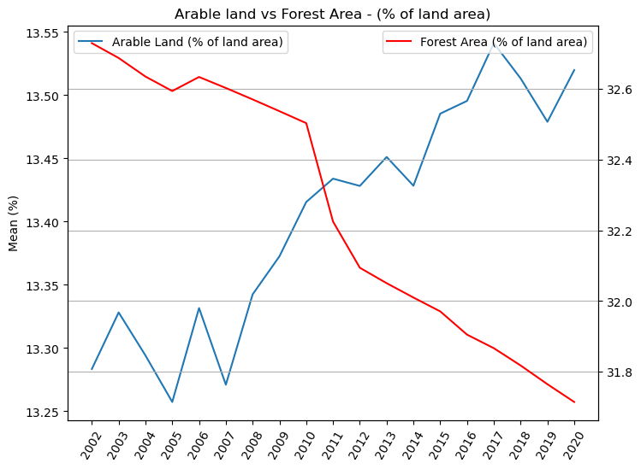

Figure 1 above shows line plots comparing the mean value of the percentage of arable land and percentage of forest area from 2002 to 2020 aggregated from the World Bank data. We can see that both lines move in an opposite direction in general. This readily tells us that as the amount of Arable land increases all over the countries in the world, the amount of forest cover decreases. Thus, arable farming negatively affects the size of forest cover which in the long run poses changes in climate as the rate of carbon removal from the air decreases with decrease in forest cover thus leading to build up of carbon dioxide which is a known greenhouse gas that accelerates climate change.

**Figure 2 :** *Mean Percentage of Arable Land across 10 Countries*

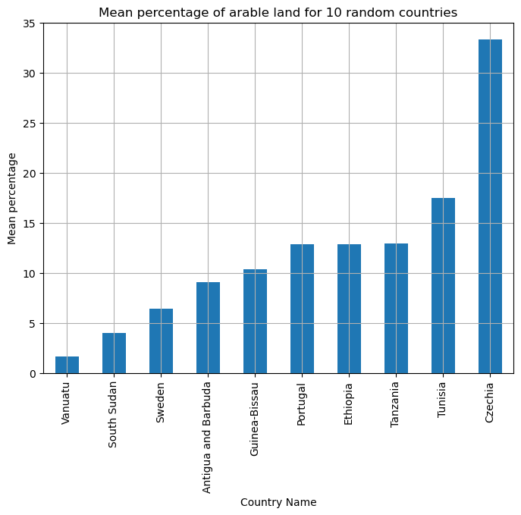

Figure 2 shows the mean percentage of arable land across 10 countries sampled out of random. We can see that the bottom three nations are Vanuatu, South Sudan, and Sweden and the top three nations are Tanzania, Tunisia, and Czechia. Sweden for instance has less than one-tenth of land that can be cultivated which is relatively small while South Sudan’s population majorly comprises of pastoralists hence minimal farming. On the other hand, Czechia has a large arable land because its geography encourages cultivation.

Figure 3 shows a pie chart illustrating the percentage of land covered by forest cover for the countries enlisted in Figure 2. We can see that, Guinea-Bissau, Sweden, and Tanzania lead in the percentage of forest covering their lands while Tunisia, South Sudan, and Ethiopia have the least amount of forest covers. Deductively, this fairly explains why Tunisia and Czechia have large arable lands as their forest cover is relatively low given the general climate of those particular nations

**Figure 3:** *Pie Chart of Percentage of Forest Cover*

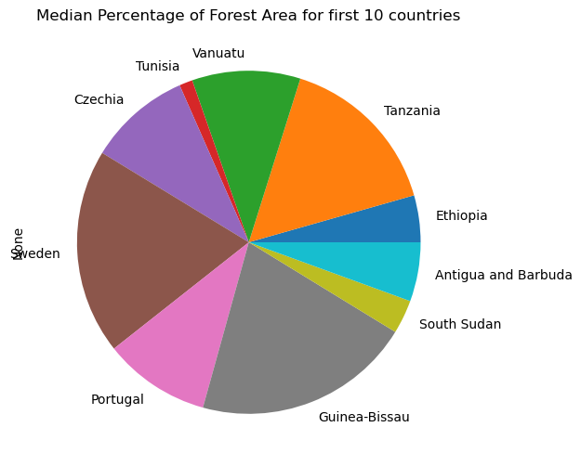

**Figure 4:** *Percentage of Arable Land per Country from 2012 - 2020*

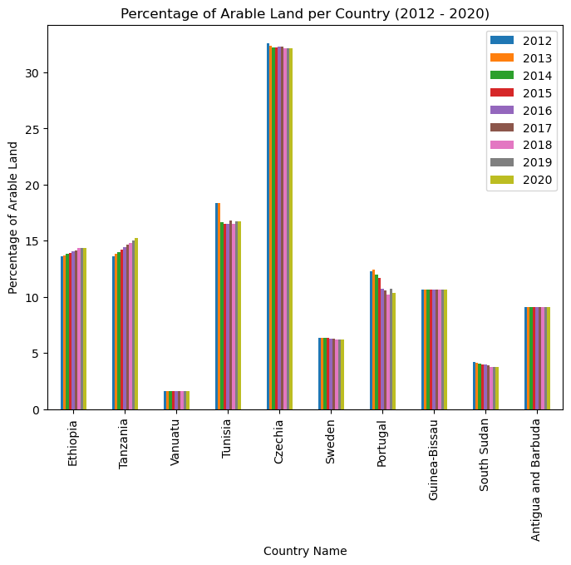

Figure 4 shows the general direction of the percentage of arable land per country from 2012 to 2020. We can see that, the size of Arable lands in Ethiopia and Tanzania have been increasing while that of Tunisia, Portugal, Sweden, and South Sudan have been decreasing. The remaining countries show no significant movement.

Figure 5 shows that the forest cover in Tanzania, Guinea-Bissau, Antigua and Barbuda, and Ethiopia have been decreasing while Portugal shows a small increase while the remaining nations remain indifferent.

**Figure 5:** *Percentage of Forest Land Per Country from 2012 – 2020*

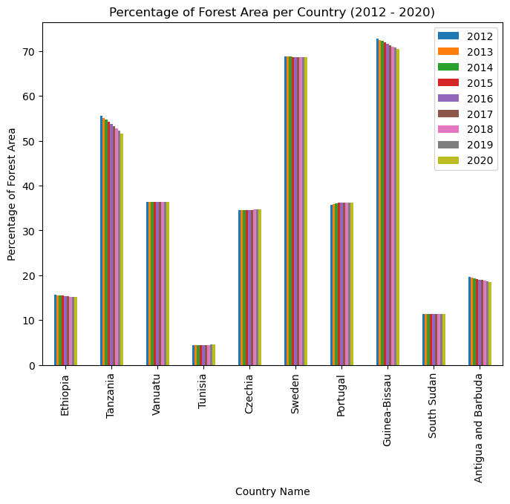

The decrease partly explains the increase in arable land for both Ethiopia and Tanzania due to increase in farming practices.

**Figure 6:** *Correlation Heatmap between Arable Land and Forest Cover per Country*

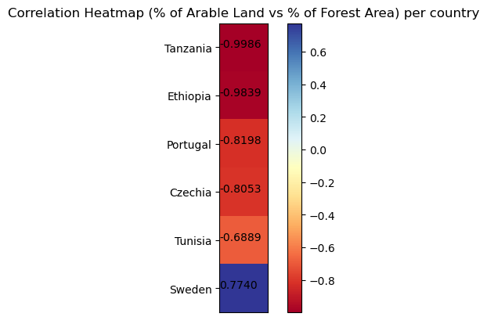

Figure 6 shows the correlation between percentage of arable land and forest cover. Only Sweden has a fairly strong positive correlation showing that the both variables have been decreasing while the rest have negative relationships as seen in Portugal whose forest area has been increasing while the size of arable land has been decreasing.